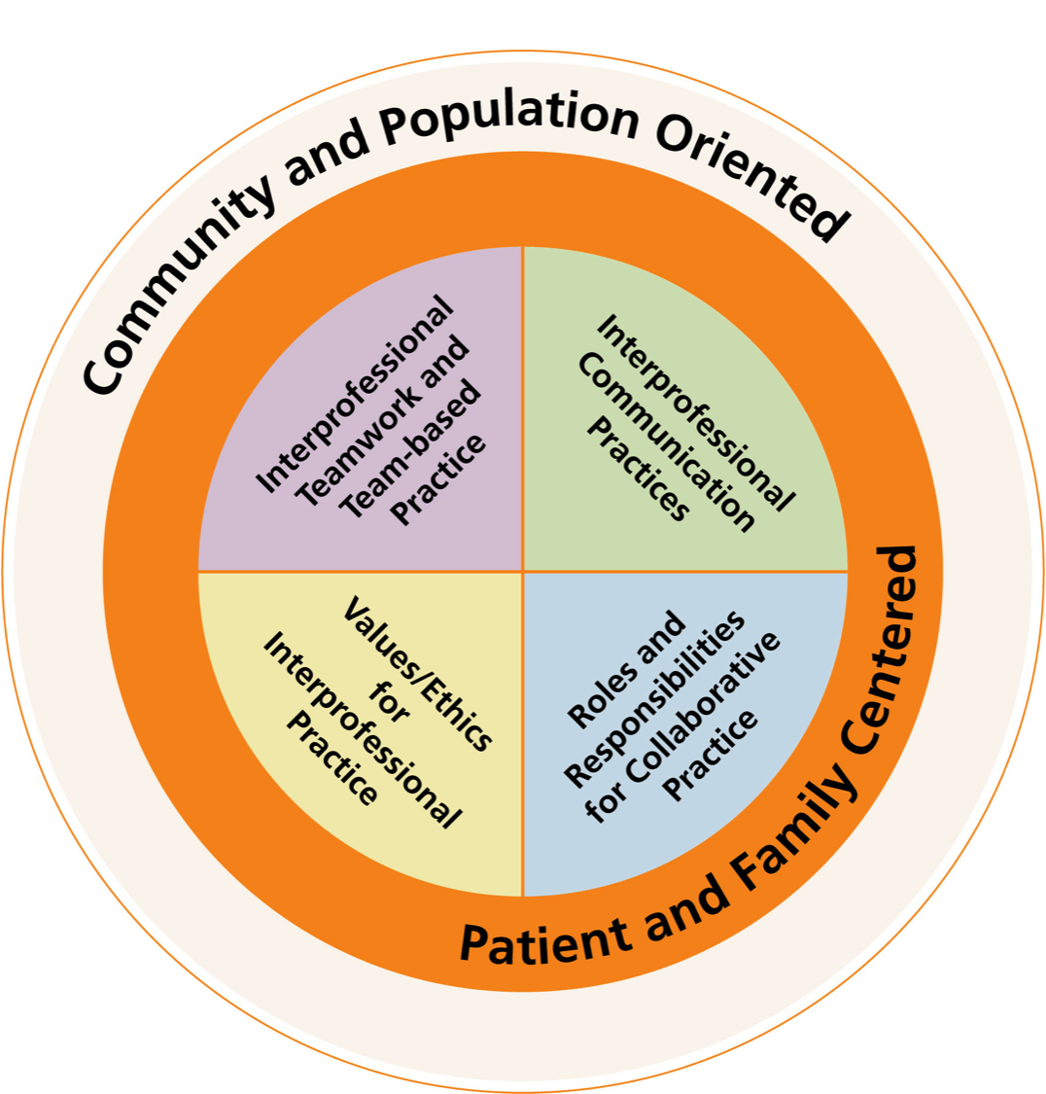

Time: 8:30 am - 12:00 pm

Location: Croasdaile Village Retirement Community, 2600 Croasdaile Farm Parkway, Durham, NC 27705
Cost: Workshop is offered at NO COST*

*Participant teams must commit to send 2-3 team members to all 3 workshops.

Dates for 2015

March 25

April 8

April 22

Who Should Attend?

Interprofessional teams who share responsibility for patient care

At least 2 members of your team need to attend each workshop

Teams may choose different members to rotate attendance at the sessions

Workshop Goals

- Identify personal and professional values and roles, and explain how they contribute to the team dynamic and collaborative practice

- Master relationship-building principles to enhance team performance

- Integrate quality improvement tools into work processes to aid team-based care

Improving Care Through Interprofessional Collaborative Practice

Workshop Description

Strengthen your team’s ability to work together to provide high quality care for your patients.

A 3–part workshop, each session building on the previous one, presenting an interactive, hands-on approach to interprofessional collaborative practice.

Register your team today for this Unique Opportunity to improve your performance as an interprofessional collaborative practice team.

  - A Three-Part Workshop Series

“The IPEC workshop brought our falls team closer together. It allowed us to be able to see other members’ viewpoints, while we gained additional skills to develop action plans. As a leader, I also gained insight into areas where good intentioned leaders may be stifling the creativity of their team.”

Roy Hudson, RN, MSN, BS, CNML
Clinical Operations Director
Duke Raleigh Hospital

“The value of participation in the IPEC workshop was that we finally developed a process for managing transitions of care that works. We'd been working on this challenge but never really got it resolved until this team took it on as a project. “

Deborah Teasley, PhD
President & CEO
Southern Regional AHEC

How Teams Will Benefit
- Work more effectively as a team with members from different professional backgrounds

- Improve communications within the team by being in touch with how individual values impact team function and contribute to the team’s shared values

- Communicate as a team in a responsive and responsible manner with patients, families, and other healthcare team members

- Analyze team performance and develop a plan to enhance team inter-professional collaborative practice

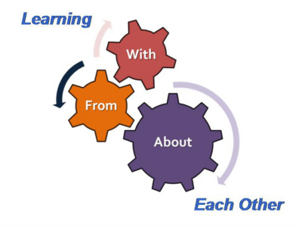 Interprofessional Education Principles

Continuing Education Credit offered for all professions

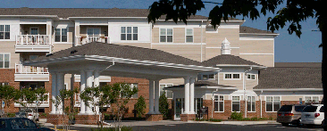
LTR
Training Location:
Croasdaile Village Retirement Community
2600 Croasdaile Farm Parkway
Durham, NC 27705

Duke
REGISTER TODAY!

Phone: 919-660-7577

michele.burgess@duke.edu

http://geriatriceducation.duke.edu/

We are excited to offer this workshop series at no cost to the participants due to grant support from the Health Resources and Services Administration Geriatrics Education Center Grant (UB4HP19203 - 0500).

