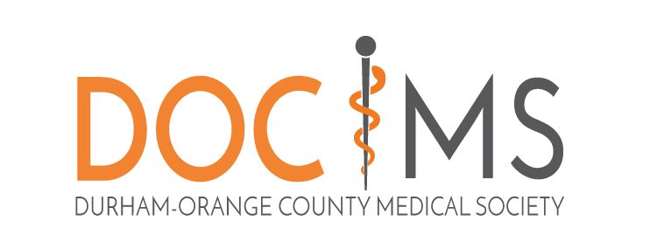 | “Life’s most persistent and urgent question is,  what are you doing for others?”  -Rev. Martin Luther King, Jr.

The Jerry Nance Community Service Award
Presented by the Durham-Orange County Medical Society

The Jerry Nance Community Service Award recognizes our community’s unsung volunteer heroes who meaningfully improve the health and well-being in these counties.

Award nominations should be sent to the attention of the Executive Director and will be evaluated by a Selection Committee. Four awards may be given to a Medical Student, Non-physician, Resident Physician and Physician. Guidelines for selection are broad. Consideration will be given to outstanding direct service activities (no monetary compensation for nominated volunteer’s work). Medical professionals will be considered for their efforts outside their “usual and expected” professional duties.

The award, a framed certificate with a $250 check payable to its recipient will be presented in April 2018.

Nomination Instructions: Deadline for receipt is Friday, March 2, 2018.

Hard copies may be mailed to:
Executive Director
Durham-Orange County Medical Society
P.O. Box 27167, Raleigh, NC 27611
Email to: docms@ncmedsoc.org

The Jerry Nance Community Service Award
Presented by the Durham-Orange County Medical Society

NOMINEE: ___________________________________________________________________________
ADDRESS: ___________________________________________________________________________
TELEPHONE NO: ______________________________________________________________________

- SIGNIFICANT BIOGRAPHICAL INFORMATION (including nominee’s occupation and name of employer)

- BRIEF EXPLANATION OF WHY THIS INDIVIDUAL SHOULD RECEIVE THE COMMUNITY SERVICE AWARD

  - What is the length of volunteer service? _________
(Describe length of project, such as total or average volunteer hours per month)

  - List name of agency volunteer services are for:_____________________________________

Name/Contact information for agency representative: ___________________________________________________________________________

Title: _______________________________________________________________________

  - What is being done by the nominee that is outstanding and deserves recognition? Concisely describe the actual volunteer work performed by the nominee (include a list of duties). Did the nominee start a new program, use new methods to solve problems, initiate activities or promote collaboration with other organizations? Describe.

  - What was the impact of this nominee’s volunteer activity upon the community’s quality of life?

  - What unusual problems or challenges, has the nominee overcome in his/her volunteer service? Did the nominee have to overcome physical or mental disabilities or limited resources? Describe.

SUBMITTED BY: ________________________________________ TITLE: ____________________________
ADDRESS________________________________________________________________________________
TELEPHONE: ______________________ EMAIL: _________________________________________________

If additional information is required, the Selection Committee will contact the person submitting the nomination.
If you have questions, please call: Durham-Orange County Medical Society Office (919) 833-3836.

