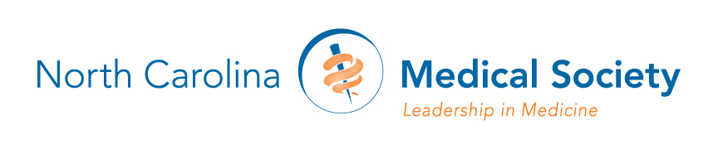

NCMS BOARD OF DIRECTORS
2018 Meeting Schedule

PROPOSED – ALL DATES AND LOCATIONS TO BE CONFIRMED

January 13 Raleigh, NC

March 17 Raleigh, NC

May 18-20 Rizzo Conference Center, Chapel Hill, NC

July 14-15 Charlotte, NC

November 3-4 Raleigh, NC

