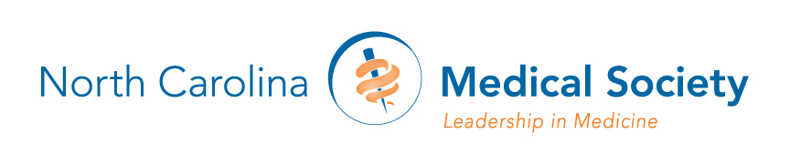

NCMS’ Brief Summary of Key Issues in 2015-17 State Budget
On September 18, the Governor signed the state’s $21.7 billion budget bill, HB 97, into law. There were many provisions related to health care included in the final draft. Take a look at our brief summary of key issues identified by the NCMS and stay tuned for a more detailed synopsis in our Bulletin publication on Wednesday.
Medicaid reform
While the majority of discussion regarding Medicaid reform took place outside of the budget (see our announcement on HB 372 below), there were a number of provisions on Medicaid reform included in the budget.
Heath Information Exchange (HIE) Funding
- Provides for $8 million in state appropriations matched by $8 million in recurring federal funding for the HIE in fiscal year 2015-2016 and 2016-2017.
- Establishes a successor HIE Network, requiring all Medicaid providers to be connected by Feb. 1, 2018 and all other entities that receive state funds for the provision of health services by June 1, 2018. Providers and hospitals must submit demographic and clinical information at least twice daily through the HIE Network.
- Establishes a state-controlled HIE Authority to oversee and administer the HIE Network and an Advisory Board to provide consultation to the Authority.
- Successor HIE Network to gradually become and remain 100 percent receipt-supported by establishing reasonable participation fees.
- The HIE Network data and products derived from the data will remain the sole property of the state. The Authority shall not allow data it receives to be used or disclosed for commercial purposes.

Medicaid transformation funding
- A portion of the funding necessary to implement the transition from fee-for-service to a capitated payment system for Medicaid as discussed in HB 372. Another appropriation will be necessary in the future.
- Creates a trigger mechanism, stating if HB 372 is not passed by 3/1/16 then the current Medicaid and NC Health Choice primary care case management (PCCM) program would be discontinued. At that time, rates paid to primary care and OB/GYN providers also would increase to 100 percent of Medicare rates to fill the primary care case management fee gap caused by discontinuation of the PCCM program. However, NCMS fully expects the legislature to pass Medicaid reform in HB 372 prior to ending the legislative session.
Prescription drug abuse Continuing Medical Education (CME) requirement
- The budget reflects legislators’ concerns over the growing problem of prescription drug abuse in North Carolina. The budget directs health care provider occupational licensing boards, including the Medical Board, to require continuing education on the abuse of controlled substances as a condition of license renewal for health care providers who prescribe controlled substances. This has been proposed multiple times in recent history. The NCMS generally opposes these types of mandates, however, with prescription drug abuse growing in North Carolina and the use of the Controlled Substances Reporting System (CSRS) remaining low, we expect this provision to be implemented in the near future. The NCMS will work with the NC Medical Board to ensure a fair and transparent application of this new requirement.
Improvements to the Controlled Substances Reporting System
- The budget calls for various improvements to the CSRS system, including enabling a state-wide connection capability, which will much improve the functionality and utility of the information stored in this database.
New Prescription Drug Abuse Advisory Committee
- Establishes a new Prescription Drug Abuse Advisory Committee in the NC Department of Health and Human Services (NCDHHS) to create and implement a new statewide strategic plan to combat prescription drug abuse.
Increased funding for inpatient psychiatric beds
- To address growing shortages of inpatient psychiatric beds in the last year, additional funding for fiscal years 2015-2016 and 2016-2017 was provided to purchase additional new or existing local inpatient psychiatric beds or bed days not currently funded by or through LME/MCOs. In addition, the Secretary of NCDHHS may use funds allocated to LME/MCOs for community-based mental health, developmental disabilities and substance abuse services to purchase additional local inpatient psychiatric beds or bed days. These funds will be appropriated to NCDHHS for the purchase of local inpatient psychiatric beds or bed days and shall not be allocated to the LME/MCOs.
Increases in Medical Examiner fees
- Provides for an increased autopsy fee of $2,800 (from $1,250) as well as an increase in the Medical Examiner fee of $200 (up from $100).

Workers compensation
- The budget instructs the Industrial Commission to study the effects of adopting a uniform prescription drug formulary in the workers’ compensation system. The study and findings are to be reported to the General Assembly by April 2016.
- Another provision extends limitations on physician-dispensed Class II and III drugs to also apply to Class IV and V drugs.

Department of Insurance/Managed Care
- Creates a new requirement that commercial health plans cover the cost of services necessary to synchronize medications when the patient, provider and pharmacist agree synchronization of multiple prescriptions is necessary in the treatment of chronic illnesses.

