Helpful Tips on Diagnosing Acute Pesticide Poisoning 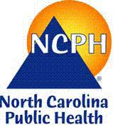

The North Carolina Pesticide Incident Surveillance Program, a program within the NC Division of Public Health, monitors the frequency of acute pesticide poisonings in the state and requires health providers to report confirmed or suspicious cases to them. Like many illnesses linked to environmental exposures, however, pesticide poisonings are commonly under diagnosed due in large part to barriers in seeking care and lack of recognition.

So how do you properly diagnose and treat a pesticide poisoning? Taking an occupational and environmental history is the first step. It is not only extremely important for diagnostic and therapeutic reasons, but for workplace corrective action and prevention counseling.
A thorough occupational and environmental history can result in these benefits:
- An accurate diagnosis increases the possibility that pesticide poisonings and other environmental exposures are recognized,
- An accurate diagnosis leads to appropriate care,
- An accurate diagnosis helps in identifying the source of exposure. This information provides the basis for education about avoiding future overexposures and correcting workplace health and safety failures.
Suggested screening questions for adult patients (EPA*):
- What kind of work do you do?
- Are your health problems related to your home or other location? (if unemployed)
- Are your health problems related to your work? (if employed)
- Are your symptoms better or worse when you are at home or at work?
- Are you now, or have you previously, been exposed to pesticides, solvents, or other chemicals, dusts, fumes, radiation or loud noise?

Want more information of diagnosing pesticide poisonings? See EPA 6th Edition Recognition and Management of Pesticide Poisonings @ http://www2.epa .gov/pesticide-worker-safety/recognition-and-management-pesticide-poisonings
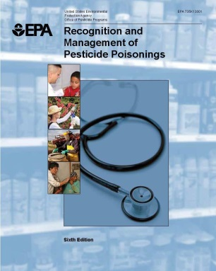
Want to report? Call Carolinas Poison Center at 1-800-222-1222.

