Draft Outline of 1/12/15 Presentation to ACO Task Force on ACOs and Risk

- Both the House and Senate Bills Contemplate Transition to Risk
  - House Bill 1181 (House Version)
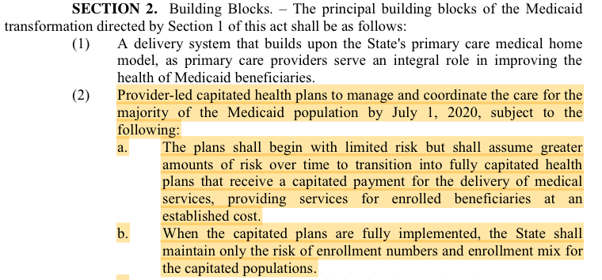
  - House Bill 1181 (Senate Version)
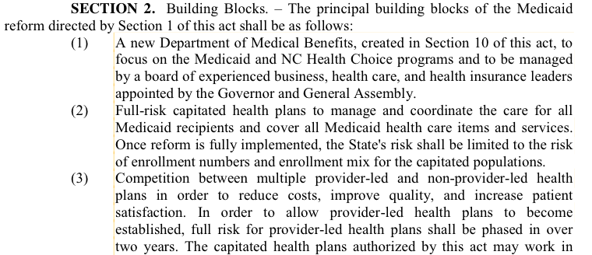
---------------------
----------------------
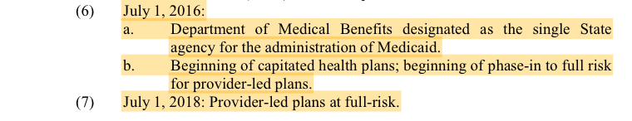
- What is “insurance”?
  - Elements of an Insurance Contract:
    - Statutory Definition:
      - “An agreement by which the insurer is bound to pay money or its equivalent or to do some act of value to the insured upon . . .”
      - “. . . as an indemnity or reimbursement for the destruction, loss, or injury of something in which the other party has an interest.”
    - Elaboration/Restatement in Case Law:
      - “Insurance is ‘a contract whereby, for a stipulated consideration, one party undertakes to compensate the other for loss on a specified subject by specified perils.’”
      - “One characteristic of an insurance contract is the shifting of a risk from the insured to the insurer. If no risk is shifted there is not an insurance contract.”
- How and why insurance is regulated
  - Why Regulate?
    - “The effect of insurance—indeed, it has been said to be its fundamental object—is to distribute the loss over as wide an area as possible. In other words, the loss is spread over the country, the disaster to an individual is shared by many, the disaster to a community shared by other communities; great catastrophes are thereby lessened, and, it may be, repaired.”
    - If an insurance company becomes unable to pay claims it has obligated itself to pay, that loss-spreading function is compromised. The claimant, whose only sin may have been bad luck, will be stuck holding the bag.
    - “The Legislature must . . . evolve a plan which will best protect the public interest and ensure the liquidity and solvency of participating insurance companies in our state who must also be assured of a reasonable profit.”
  - Basic Financial Responsibility Requirements for North Carolina Accident and Health Insurers
    - Capital Deposit, Additional “Risk Based Capital,” Reserve Requirements, Annual Reporting.
    - Specific numbers vary depending on type and size of insurer and nature of risk portfolio. [Can Bill Barnett provide a ballpark number for a typical health insurer?]
- Distinguishing Insurance Risk from Business Risk
  - Transition
    - Risk must be shifted for a contract to be considered insurance, but risk-shifting alone is not enough.
    - All sorts of contracts involve the assumption of risk, but aren’t regulated as insurance:
      - Example 1: All-you-can-eat buffet
      - Example 2: [Provider-relevant example of non-insurance risk in ordinary business contract. Invest in equipment, run risk of new technology that will render it obsolete?]
  - How to tell whether a particular contract involves business risk or insurance risk:
    - In general courts use the “principal purpose” test: Is the principal purpose of the contract to shift risk? Or is the principal purpose to purchase services?
    - Some relevant questions:
      - How likely is it that the purchaser will actually utilize the service being offered? If there’s only a small chance of utilization, a court is more likely to say that the principal purpose is risk-shifting.
        - Not Insurance: For a flat monthly fee, a company agrees maintain a vehicle, including not just mechanical and body repairs, but also gas, monthly washing, yearly paint jobs, obtaining insurance, etc.
        - Insurance: For a one-time fee, a car dealer agrees to repair any mechanical malfunction that occurs during a specified period of time, with no payment from the customer aside from a $25.00 per-incidence fee, but regular maintenance is the purchaser’s responsibility.
        - Health Context: primary care (routine; everybody needs it) vs. emergencies (most people will not need)
      - Does the entity provide most of the services itself? Or is it just an intermediary, obtaining services from third parties? If the entity is obtaining services from third parties, a court is more likely to say the principal purpose is risk-shifting.
    - 1939 D.C. Circuit Case: Jordan v. Group Health Association
      - Facts: Members paid flat monthly fee to Group Health; Group Health was obligated to arrange for whatever medical services members needed (by contracting with independent providers).
      - The court determined that this was not a contract for insurance.
        - “Although Group Health’s activities may be considered in one aspect as creating security against loss from illness or accident, more truly they constitute the quantity purchase of well-rounded, continuous medical service by its members.”
        - “There is, therefore, a substantial difference between contracting in this way for the rendering of service even on the contingency that it be needed, and contracting merely to stand its cost when or after it is rendered.”
    - 1996 Attorney General Opinion on Direct Contracting
      - In 1996, the Attorney General issued a legal opinion stating that a provider group who contracted with a self-insured employer plan on a prepaid, capitated basis did not take on insurance risk because “the principal purpose of the . . . contract is obtaining health care services, not protecting against a financial risk.”
- HMOs
  - What is an HMO?
    - Statutory Definition: An entity that “undertakes to provide or arrange for the delivery of health care services on a prepaid basis except for enrollee responsibility for copayments and deductibles.”
  - Are HMOs “Insurance”?
    - Under the analysis above, whether an entity is provider-led or simply has providers as employees is not relevant. Thus, a staff-model HMO would probably not be considered insurance.
    - Indeed, some courts have specifically held that HMOs are not insurance.
    - This is part of the reason state legislatures adopted legislation specifically directed at ACOs.
    - Key Point: Whether an entity is doing insurance is not the same question as whether it’s an HMO.
  - Financial Requirements
    - Minimum Net Worth: At least $1 million; potentially more.
    - Liquidity Requirement: $500,000 deposit for full-service HMOs.
    - Planning & Reporting: Every HMO “shall have and maintain at all times an adequate plan for protection against insolvency acceptable to the Commissioner.”
    - Exceptions:
      - “This Article does not apply to
        - “any prepaid health service or capitation arrangement implemented or administered by the Department of Health and Human Services or its representatives, pursuant to 42 U.S.C. § 1396n or Chapter 108A of the General Statutes,
          - [Does this completely exempt Medicaid ACOs?]
        - “a provider sponsored organization or other organization certified, qualified, or otherwise approved by the Division of Medical Assistance . . . pursuant to Article 17 of Chapter 131E of the General Statutes, or to
        - “any provider of health care services participating in such a prepaid health service or capitation arrangement.”
      - “[T]o the extent this Article applies to any such person acting as a subcontractor to a Health Maintenance Organization licensed in this State, that person shall be considered a single service Health Maintenance Organization.”
        - Single service HMOs have lower liquidity and net-worth requirements. (minimum $100,000 startup capital; $50,000 ongoing capital; $25,000 cash deposit)
- Application to ACOs
  - Arguments that Insurance regulators will make:
    - Statutory Presumption: Any entity that provides medical coverage in North Carolina, “whether the coverage is by direct payment, reimbursement, or otherwise, shall be presumed to be subject to the jurisdiction of the [Insurance] Commissioner.”
    - The fact that a contract for insurance risk has been bundled up with a contract for medical services does not make the insurance risk any less insurance risk.
    - The “duck” test: if it looks like an HMO . . .
  - Fee-for-Service Base with Shared Savings (e.g., Medicare Shared Savings ACOs)
    - Probably not insurance, because much closer to a classic contract for services than an insurance contract.
    - Probably not an HMO, because not prepaid.
  - Capitation Base with Risk Corridors
    - Probably not insurance under cases discussed above, but uncertain due to lack of NC-specific law on point. The more risk exposure, the more likely a court would find that risk-shifting is the “principal purpose.”
    - Probably an HMO, but remember exception for Medicaid, and loosened financial requirements for downstream contractors.
  - Full Capitation
    - Arguably not insurance under cases discussed above, but even more uncertain due to lack of NC-specific law on point.
    - Probably an HMO, but remember exception for Medicaid, and loosened financial requirements for downstream contractors.
  - Bottom Line:
    - If an ACO took on a capitated contract, and then the Insurance Commissioner sued it, claiming it was providing insurance without a license, who would win? Current law leaves that as an open question.
    - The provider community should seek legislation, as part of Medicaid reform or otherwise, that clarifies the regulatory implications of taking on downside risk.
  - Aside: Insurance Risk vs. Performance Risk
    - This distinction is not in the case law, but it is a useful concept, and shows up often in the ACO literature.
    - In general, provider performance cannot influence the underlying prevalence of injury and disease in the population; e.g., the number of people who get cancer. This is “insurance risk.”
      - [Caveat about preventative care like smoking cessation]
    - Provider performance can influence the number of episodes of care for a given condition, and the quantity of services provided per episode. This is performance risk.
- Current Approaches in Medicare & Other States
  - Federal approaches
    - Medicare Shared Savings Program ACOs
      - Nature of Downside Risk:
        - Under MSSP Track 2, if ACO expenditures exceed the pre-set benchmark, ACO may be required to pay up to 60% of the difference between the benchmark and actual expenditures, capped at 10% of the total benchmark expenditures.
      - Approach to State Insurance Regulation:
        - CMS believes that it “will continue to bear the insurance risk associated with the care furnished to Medicare beneficiaries,” but noted that “ACOs desiring to participate in Track 2 should consult their State laws.”
      - Financial Requirements:
        - “Repayment Mechanism” of at least 1 percent of the ACO’s total per capita Medicare Parts A and B fee-for-service expenditures for its assigned beneficiaries.”
        - Can use escrow funds, surety bond, or letter of credit.
    - Medicare Pioneer ACOs
      - Nature of Downside Risk: variable, but up to full capitation.
      - Approach to State Insurance Regulation:
        - “Applications must include either an attestation that the organization has been licensed by the state in which it is located as a risk-bearing entity, or that it is exempt from such licensure or other related licensure requirements.”
      - Financial Requirements:
        - Must provide “enforceable assurances” that the ACO “can reimburse Medicare for all potential losses.”
        - Can be an irrevocable letter of credit or “any similarly enforceable mechanism.”
    - Medicare Advantage Physician Incentive Plans
      - Nature of Downside Risk:
        - MA contracts with HMO; HMO in turn contracts with a provider group in a manner that places the provider group at “substantial financial risk” (defined as the potential to have to spend more than 125% of total payments)
        - Key: downstream from licensed HMO; no direct contract with Medicare
      - Approach to State Insurance Regulation: Does not address
      - Financial Requirements:
        - Stop Loss: 90 percent of the costs above 125% of total payments (or similar per-patient stop-loss coverage)
    - Medicare Advantage PSOs
      - Nature of Downside Risk:
        - CMS pays fixed fee to PSO; PSO agrees to provide at least all services covered by Medicare.
      - Approach to State Insurance Regulation:
        - Federal regs set out financial-responsibility requirements for PSOs; any state requirements more stringent than the federal ones are preempted.
        - North Carolina enacted a state-specific statute, in which it preempted regulation by the Insurance Department, provided that PSOs were to be regulated by the Division of Medical Assistance instead, and set out alternate requirements consistent with the federal PSO regs.
      - Financial Requirements:
        - Minimum Net Worth:
          - At Startup: $1.5 million (potentially lower for PSOs with administrative infrastructure already in place, or PSOs operating in rural areas)
          - Ongoing: At least $1 million; potentially more depending on size of PSO.
        - Liquidity:
          - At Startup: $750,000 cash or cash equivalent
          - Ongoing: “Sufficient cash flow to meet its obligations as they become due.”
  - Other States
    - Massachusetts “Risk Bearing Provider Organizations” (“RBPOs”) (Public and Commercial)
      - Nature of Downside Risk:
        - Any provider organization that bears downside risk pursuant to a non-FFS contract is an RBPO.
        - Regulatory requirements can be waived, however, if the downside risk isn’t “significant,” in the opinion of the Insurance Commissioner.
      - Approach to State Insurance Regulation:
        - RBPOs are exempt from regulation as insurance companies or HMOs.
        - Instead, they must obtain a “risk certificate” (or a “risk certificate waiver,” if the downside risk isn’t “significant”)
      - Financial Requirements:
        - An actuarial certification that the RBPO’s payment contracts “are not expected to threaten the [RBPO’s] financial solvency.”
    - Illinois “Accountable Care Entities” (Medicaid)
      - Nature of Downside Risk: 3-Phase Program
        - Phase 1: Fee-for-service payment, plus supplemental $9 per-member per-month care-coordination fee, plus potential shared savings. (Months 1–18.)
        - Phase 2: Prepaid capitation, but state retains a portion of the risk through stop-loss insurance and risk corridors. (Months 19–36.)
          - Stop-Loss: state will cover 80% of expenditures above $80,000 for any particular enrollee
          - Risk Corridors: state will cover 80% of any costs above a 110% medical loss ratio.
        - Phase 3: Full capitation, without stop-loss or risk corridors. (After 36 months.).
        - After conversion to full capitation, ACEs become “managed care community networks” (“MCCNs”), which are separately regulated.
      - Approach to State Insurance Regulation:
        - Intent appears to have been to wait until Phase 3 (conversion to MCCN) to regulate risk.
        - But in the contract solicitation, the State said that “[b]ased on current Illinois law,” Phase 2 structure “requires an ACE to be a MCCN or HMO by month 19.”
      - Financial Requirements:
        - During Phase 1, none (because no downside risk).
        - Starting in Phase 2, the MCCN requirements apply. Under the latest proposed amendment to those rules, the financial requirements are
          - $500,000 net worth before certification
          - After certification, $500,000 net worth, but potentially more based on amount of risk
          - At least $250,000 of that net worth in case or cash equivalents.
- What is Feasible in North Carolina?
  - What are the Options?
    - Options to Avoid:
      - Don’t address the issue; leave it to the courts to figure out whether ACOs are taking on insurance risk.
        - Unpredictable and all-or-nothing
      - Rules that don’t’ recognize the wide variance in exposure to risk among different ACOs and different contracts.
    - Options to Think About:
      - Stay with fee-for-service + shared savings & losses; safely avoid insurance/HMO regulation
        - Example: Current MSSP Program
      - Preempt insurance regulations; set out alternate substantive financial requirements tied to level of risk; whether the ACO is downstream of a licensed insurer
        - Lots of ways to do this:
          - Shared-savings withholds?
          - Stop-Loss?
          - “Enforceable assurances” (i.e., letters of credit)?
          - Manageable capital requirements?
          - Note: these can be used in combination, or one can transition into the other (e.g., use shared-savings withholds to establish capital reserves during transition period to full risk).
        - Examples: Illinois
      - Punt to actuaries
        - Example: Massachusetts requirement that risk-bearing provider organizations obtain an actuarial certification that their contracts do not threaten their solvency.
  - What are the limitations?
    - What is the legislature willing to enact?
    - What is the Department able to administer?

HB 1181, House-Passed Version.
HB 1181, Senate-Passed Version.
N.C. Gen. Stat. § 58-1-10.
Henry Angelo & Sons, Inc. v. Prop. Dev. Grp., 63 N.C. App. 569, 574 (1983) (alteration omitted) (quoting Black’s Law Dictionary 943 (rev. 4th ed. 1968)); Gibbs v. Mayo, 162 N.C. App. 549, 566 (2004) (same quote).
Blackwelder v. City of Winston-Salem, 332 N.C. 319, 322 (1992).
German Alliance Ins. Co. v. Lewis, 233 U.S. 389, 412–13 (1914).
State ex rel. Hunt v. N.C. Reinsurance Facility, 302 N.C. 274, 297 (1981).
See, e.g., Jordan v. Grp. Health Ass’n, 107 F.2d 239, 248 (D.C. Cir. 1939); Cal. Physicians’ Serv. v. Garrison, 28 Cal.2d 790, 809 (1946) (en banc).
Transp. Guar. Co. v. Jellins, 29 Cal.2d 242 (1946) (en banc).
McMullan v. Enter. Fin. Grp., Inc., 247 P.3d 1173 (Okla. 2011); Jim Click Ford, Inc. v. City of Tucson, 154 Ariz. 48 (Ariz. Ct. App. 1987).
Jordan v. Grp. Health Ass’n, 107 F.3d 239 (1939).
Id. at 247.
Id.
NCDOJ, Advisory Opinion: Durham County Hospital Corp—Contracting with Self-Insured Employee Benefit Plans and Health Care Providers (1996).
N.C. Gen. Stat. § 58-67-5(f).
N.M. Life Ins. Guar. Ass’n v. Moore, 93 N.M. 47 (1979).
N.C. Gen. Stat. § 58-67-110(b).
N.C. Gen. Stat. § 58-67-25; id.§ 58-67-110(a).
N.C. Gen. Stat. § 58-67-110(e).
N.C. Gen. Stat. § 58-67-10(3a).
Id.
N.C. Gen. Stat. § 58-49-5.
42 C.F.R. § 425.606(f), (g).
U.S. Dept. of Health & Human Services, Ctrs. For Medicare & Medicaid Services, “Medicare Program; Medicare Shared Savings Program: Accountable Care Organizations” (2011 Final Rule), 76 Fed. Reg. 67802, 67816.
42 C.F.R. § 425.204(f)(1).
42 C.F.R. § 425.204(f)(2). The 2011 MSSP rule also allows ACOs to use reinsurance, but no ACOs have been able to obtain reinsurance, and CMS has proposed to remove reinsurance as an option in the next MSSP rule.
Center for Medicare and Medicaid Innovation, Pioneer ACO Model Request for Application, ¶ III.K.
Id.
42 C.F.R. § 422.208(d).
42 C.F.R. § 422.208(f).
42 U.S.C. §§ 1395w-22 (defining minimum benefit package for Medicare Advantage organizations); 42 U.S.C. § 1395w-23 (providing for monthly capitation payments to Medicare Advantage organizations); 42 U.S.C. § 1395w-25 (creating PSOs as a type of Medicare Advantage organization).
42 C.F.R. §§ 422.380–390 (establishing PSO-specific financial responsibility requirements); 42 U.S.C. § 1395w-25(a)(2)(D) (preempting more stringent state standards).
N.C. Gen. Stat. §§ 131E-275 et seq.
N.C. Gen. Stat. § 131E-282(a)(2).
N.C. Gen. Stat. § 131E-286(a).
N.C. Gen. Stat. § 131E-282(a)(3).
N.C. Gen. Stat. § 131E-288(a)
Mass. Gen. Laws ch.176T, § 1 (defining RBPOs).
211 Mass. Code Regs. 155.05(1).
Mass. Gen. Laws ch. 176T, § 2.
Mass. Gen. Laws ch. 176T, § 3; 211 Mass. Code Regs. 155.05(1).
211 Mass. Code Regs. 155.06.
See generally 305 Ill. Comp. Stat. 5/5-30(g).
Illinois Department of Healthcare and Family Services, Solicitation for Accountable Care Entities, ¶ 3.1.6.3.
Id. ¶ 3.1.6.4.
Id. ¶ 3.1.6.5.
Ill. Admin. Code tit. 89, § 143.300 (proposed revised version).

