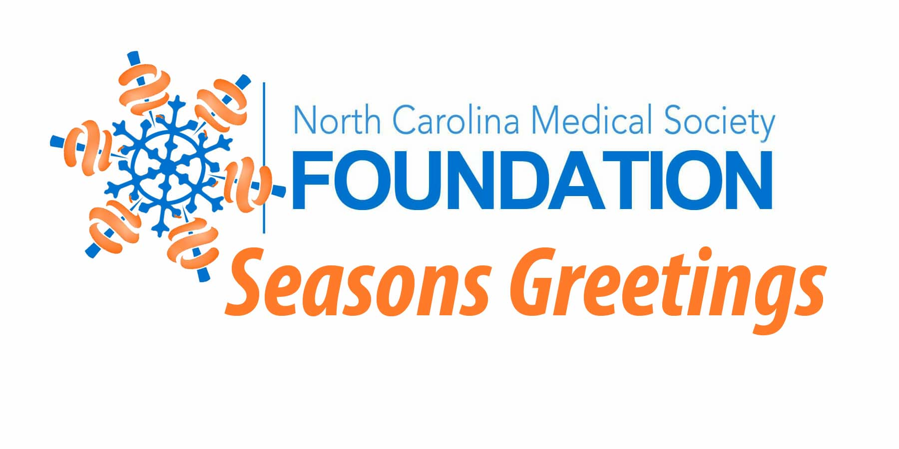

Regardless of payment method, please fax form to 919-833-2023
so that we can process your cards ASAP
Donor Name(s): ________________________________________________________________
Address: _________________________________________________________________
_________________________________________________________________
E-mail Address: _________________________________________________________________
Yes! I would like to honor ________ special people. My tax-deductible gift is $____________ ($35 for one card / $100 for three cards / $150 for five cards).
Payment Options:
Enclosed is my check made payable to the NCMS Foundation.
Please bill my credit card (Visa, Mastercard or American Express) as follows:
Card Number: _______________________________________________ Exp. Date: _______________
3-digit security code: ________________ Name as it appears on card: ___________________________
Signature: ______________________________________________
Please send a card to (please list name and address for mailing purposes):

Card 1 Recipient Name:  Recipient Address:  Card Option:  Personalized Message: | Card 2 Recipient Name:  Recipient Address:  Card Option:  Personalized Message:
Card 3 Recipient Name:  Recipient Address:  Card Option:  Personalized Message: | Card 4 Recipient Name:  Recipient Address:  Card Option:  Personalized Message:
Card 5 Recipient Name:  Recipient Address:  Card Option:  Personalized Message: | Card 6 Recipient Name:  Recipient Address:  Card Option:  Personalized Message:
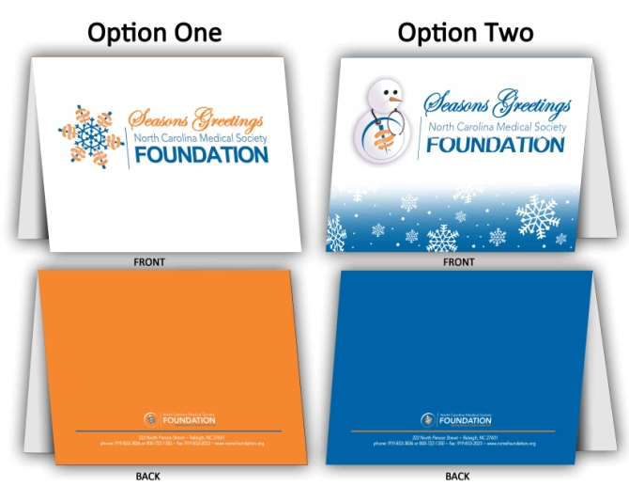
Return by December 19, 2014 to:
NCMS Foundation
PO Box 27167
Raleigh, NC 27611
Fax: (919) 833-2023
Email: phighsmith@ncmedsoc.org

