NCOA & You: Worth the Investment

The North Carolina Orthopaedic Association (NCOA) is the state’s only professional association dedicated to representing our specialty and promoting excellence in patient care. Our number one goal is to support orthopaedic surgeons in North Carolina through education, communications, advocacy and professional relations. With your support and participation, our NCOA is better positioned to present a strong and unified voice on the issues that impact our specialty and patients.

We strive to keep you continuously informed of our activities and opportunities for your involvement through our email newsletter. Recent editions are available for your inspection on our website, www.ncorthopaedics.org. You will find that we are working hard to meet or exceed your expectations in these areas. As a dues driven organization, we rely on membership support to provide quality programs and services to the orthopaedic surgery community in our state. Please support our efforts by joining NCOA as an Active Member.

We are currently engaged in a variety of worthwhile initiatives, including:

- Advocating for reform of the state’s anti-competitive Certificate of Need (CON) laws
- Mobilizing members to represent the orthpaedic surgery community’s concerns as Medicaid reform is implemented in North Carolina
- Partnering with the Toward Accountable Care Consortium to develop specialty-specific resources that can ease your practice’s transition from fee-for-service to new payment models
- Working with payers to keep you informed of policy changes that impact your bottom line
- Coordinating with the AAOS to maximize our effectiveness in advocating for quality orthopaedic care at the national level
- Responding to concerns over appropriate supervision restrictions for PAs and NPs
- Monitoring and responding to legislative issues, including:
  - HB 200, Reform Certificate of Need Laws
  - SB 702, Repeal CON and COPA Laws
  - HB 135/SB 170, Modernize PT Practice (Spinal Manipulation)
  - HB 306, Chiropractic Co-Pay Parity
  - HB 683, Occupational Therapy – Choice of Provider
  - SB 157, Enhance Patient Safety in OR (Circulating Nurse)
- Preserving our medical liability reform success of 2011
- Planning for another outstanding NCOA Annual Meeting
- And more . . .

Take a look below to learn more about our programs and services. WARNING: You may be surprised by all that NCOA has to offer! We're working to give you the best in service and support. Please consider becoming an NCOA member. Learn more at www.orthopaedics.org or contact us at ncoa@ncmedsoc.org for more information.

Education: Quality, Convenience & Affordability
Receive quality education at the NCOA Annual Meeting where attendees earn education credits, network with colleagues and are updated on key advocacy issues. Meetings typically draw 80-100 physicians and many vendors. The 2016 NCOA Annual Meeting will be held October 7-9 at the Pinehurst Resort. Members enjoy a discounted registration rate.
Program and registration information: http://www.cvent.com/d/8fq61x

Communications & Media Relations
The NCOA disseminates information to our members, the larger health community and the public through a variety of communications vehicles. NCOA members receive periodic email newsletters and time-sensitive “action alerts” on urgent matters so you can participate when your help is needed most.
Read the latest e-newsletters online at www.ncorthopaedics.org.

Professional Relations
The NCOA maintains close relationships with our partner organizations. We work frequently with other physician groups, residency programs, and various health agencies. The NCOA, through the resources of the North Carolina Medical Society (NCMS), provides assistance with members’ regulatory and payer issues. Our strong relationship with the NCMS and other physician specialty organizations resulted in the recently updated workers’ compensation fee schedule that took effect on July 1, 2015.
Read more about the new Workers' Comp Fee Schedule in our March e-newsletter at http://bit.ly/NCOA20150305.

Legislative & Political Affairs
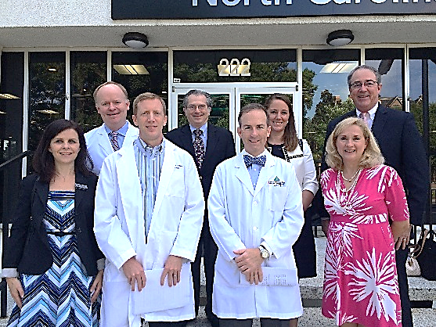
Direct lobbying of the N.C. General Assembly is just one component of our effective advocacy strategy. Through NCOA PAC—our political action and education committee—we work to identify and support candidates to advance the NCOA position on key legislative issues. We encourage and facilitate grassroots activities, strengthening our members’ local advocacy efforts. We also host events with legislators in Raleigh. Contact us at ncoa@ncmedsoc.org for advocacy assistance.
