A Resident Curriculum on Physician Impairment by Substance Abuse:
Final Report

Physician impairment by substance abuse is an important medical and legal issue that is rarely adequately addressed in physician training programs. Just as airline pilots and truck drivers are closely monitored for substance abuse due to potential harm of the public, physicians should be monitored closely for signs of abuse to ensure patient safety.^{3,4}
Several studies of medical students, residents and practicing physicians reveal that physicians are as likely as their age and gender-matched peers to use illicit substances. There is some evidence that alcohol use may actually be higher among physicians, compared to peers, however, socioeconomic status may be a confounding variable. Finally, there is also a suggestion that physicians have a unique issue of self-treatment with controlled medications.¹
Residency training, in particular, is a very demanding period in a young physician’s career. Habits established during this time of life may affect future impairment and potential legal implications.²
This project was aimed at first helping residents to understand the prevalence of substance abuse among physicians. This often seemingly distant issue was made more identifiable to residents by having a speaker, Dr. Clark Gaither, who is a physician recovering from substance abuse, discuss his story. Hearing Dr. Gaither’s story helped residents appreciate that substance abuse can be a problem for physicians, just like themselves and their colleagues. In addition, it also showed how a physician with substance abuse can recover and continue to be a very productive and admired physician.
The second aim of the project was to help residents identify physician impairment in themselves and others. Through a lecture provided by Dr. Warren Pendergast of the North Carolina Physicians Health Program the residents were taught how to identify signs of physician impairment, understand the process for dealing with physician impairment, and potential consequences of such a problem.
Prior to the educational session, residents completed a survey (Figure 1), which helped to assess their baseline knowledge of physician impairment and the role of the North Carolina Physicians Health Program. The residents then took the same survey after the session to assess the knowledge gained from the didactic session. Residents showed an improved knowledge of the topics discussed after the intervention.
Overall the residents gained knowledge and understanding of the problem of physician impairment by substance abuse. The ACP grant enabling transportation for our speakers and lunch for our residents was a major reason for the project’s success.
As a follow-up to the initial educational session, we have a seminar scheduled for this month (February 2016) where concepts introduced during Dr. Pendergast’s presentation will be reviewed and expanded upon. This seminar will also address burnout, which is often linked to physician impairment. Residents will review strategies to prevent burnout, how to identify burnout and impairment, and resources that can be used to address burnout and/or impairment. Residents will also be able to participate in three different activities, which will serve as creative outlets for them as a “hands-on” demonstration of one method that can be used to prevent burnout. We anticipate using the remaining $581.58 left in this fund to support this seminar.

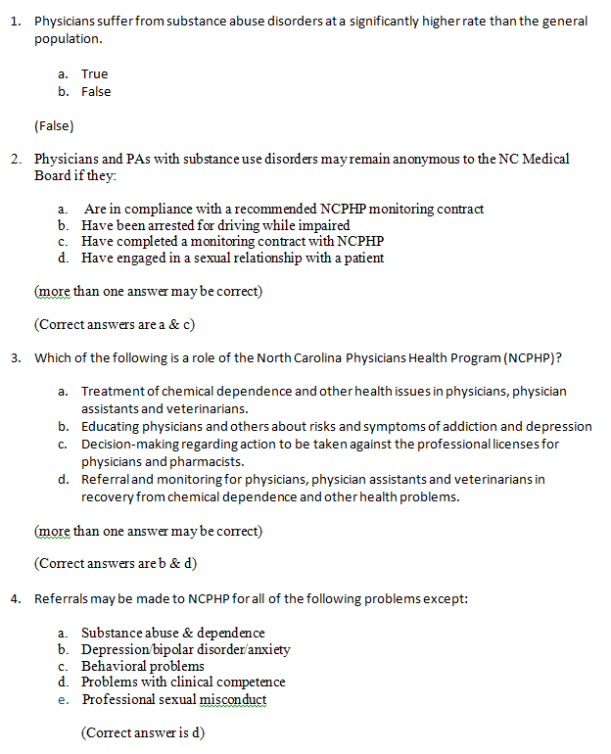
Figure 1. Pre- and Post-Survey

References
- Hughes PH, Bradenburg N, Baldwin DC, Storr CL, Williams KM, Anthony JC, Sheehan DV. Prevalence of Substance Use Among US Physicians. JAMA. 1992;267:2333-2339.
- Hughes PH, Conard SE, Baldwin DC, Storr CL, Sheehan DV. Resident Physician Substance Use in the Unites States. JAMA. 1991;265:2069-2073.
- O’Connor PG, Spickard A. Physician Impairment By Substance Abuse. Medical Clinics of North America. 1997, July;81(4):1037-1050.
- Pham JC, Pronovost PJ, Skipper GE. Identification of Physician Impairment. JAMA. 2013, May;309(20):2101-2102.

