A Resident Curriculum on Nutrition Counseling and Wellness:
Final Report

Resident physicians do not receive adequate training in weight counseling and nutrition¹. Furthermore, overweight physicians are less likely to counsel their patients², and the obesity rate of physicians is approaching that of the general population³. In order to respond to the obesity epidemic in the United States, we must improve nutrition education in our training programs.
Through the support of the ACP educational project grant, we developed a nutrition curriculum in an effort to empower our residents to teach the basics of nutrition to their own patients, and hopefully, in the process, improve their own nutrition habits.
The session started with showing the residents free resources that they could suggest to their patients such at the choosemyplate.gov website and nutrition.org. We then moved on to discuss some basic nutrition principles such as resting metabolic rate, the success rates of different diet strategies in the short-term as well as several years out, portion control, and eating frequency. We also discussed how physicians can raise awareness in their own patients about their BMI, the interpretation of this number, and how to discuss some healthy goals to make about weight loss. The residents were introduced to the National Weight Control Registry.
We had a short session about healthy substitutions and then they were able to sample several different foods made with healthy substitutions.
We were fortunate to enlist the help of two registered dieticians who were affiliated with Wake Forest School of Medicine. They helped develop the curriculum and were also present to help with each session. The residents had an allotted time to ask them any questions they had about nutrition.
We then presented the concepts between four different diets for chronic diseases: DASH, renal diet, consistent-carb diet and low-calorie diet. This involved discussion regarding what the nutrition guidelines were for each diet, what the indications were for the diet, and then some discussions about different foods that needed to be limited in each diet.
The Brenner Fit kitchen, which is affiliated with the children’s hospital at Wake Forest, allowed us to use their kitchen. This facility has four cook tops and all of the utensils necessary to prepare meals. The residents were divided into four groups and each prepared a meal that was in accordance with the diets discussed previously. They were all variations on the same meal, so that the residents could see which foods had to be changed to be in compliance with the different diets. At the end, they were able to sample each other’s food.
A pre-test done prior to the session showed that approximately 75% of our residents know their BMI. Also noted from this pre-test, approximately 50% of those surveyed noted that they occasionally tell their patients their BMI and what it means. To determine the usefulness of this curriculum, a post test was performed to determine the residents’ perceptions of the session. The average score for the session was a 9.2 (1 being ‘not very helpful’ and 10 being ‘very helpful’). In regards to what they would use in their own lives from the session, many residents talked about the choosemyplate.gov website, portion control and healthy substitutions. For patients, residents stated that they would refer them to choosemyplate.gov, discuss portion control, increase their referrals to nutritionists, and one person mentioned learning about the importance of a non-judgmental attitude, and being persistent and patient with his or her patients. The nutrition curriculum was well-received by residents, and we feel that the ACP grant was a major reason for its success.
Since the completion of the initial resident curriculum on nutrition counseling and wellness, the NC ACP educational project grant has continued to be used for further nutrition counseling and wellness initiatives in our residency program. We are fortunate to have been able to use funds from the grant to support nutrition seminars to educate residents over three academic years. At the request of the residents, we have repeated a very well-received seminar on “healthy eating for residents”. During this seminar, a focus is placed on recipes that are not only healthy, but also quick, easy, and inexpensive to make. Four tasting stations at the seminar allow residents to sample the dishes and exchange recipes. One of the stations featured a taste testing of healthy microwavable lunch options (along with a new microwave to encourage residents to pack healthy lunches). Residents also played a game of “Eat This, Not That” emphasizing healthy options sold at the medical center. We have a follow-up seminar scheduled for this academic year (spring of 2016) accompanied by a progressive dinner where residents again make and share healthy recipes with one another. We anticipate using the remaining $814.42 left in this fund to support these events.

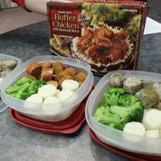
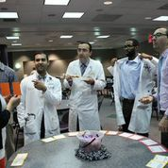
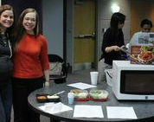
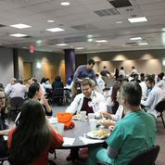
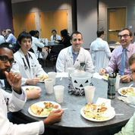
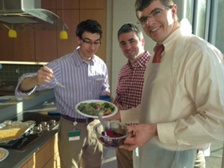

References

1. Bleich SN, Gudzune KA, Bennett WL, Cooper LA. Do physician beliefs about causes of obesity translate into actionable issues on which physicians counsel their patients? Prev Med. 2013 May;56(5):326-8.

2. Bleich SN, Bennett WL, Gudzune KA, Cooper LA. Impact of physician BMI on obesity care and beliefs.
Obesity (Silver Spring). 2012 May;20(5):999-1005.

3. Lesser LI, Cohen DA, Brook RH. Changing eating habits for the medical profession. JAMA. 2012 Sep 12;308(10):983-4.

